**Tomcat**

Step:1

. install tomcat server

Login mobaxterm with public ip

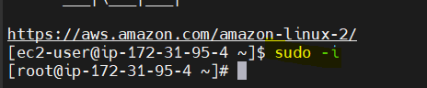

. install java and tomcat packages (<https://tomcat.apache.org/download-90.cgi>)

. copy latest package download



. un zip tar file

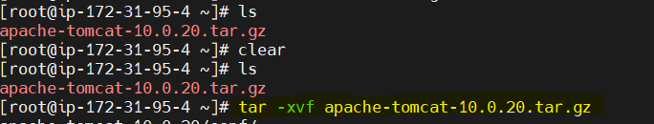



. change directory

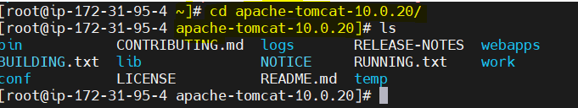

. create directory to copy unzipfile

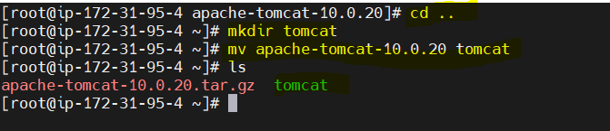

Start tomcat service

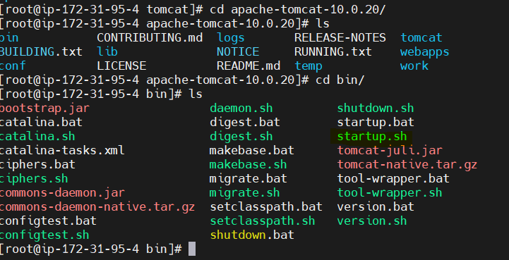

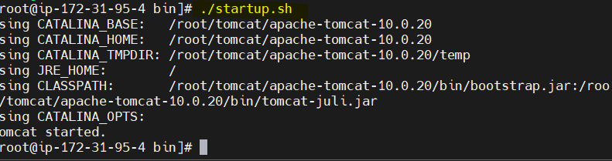

. go to service copy ip address, paste on google

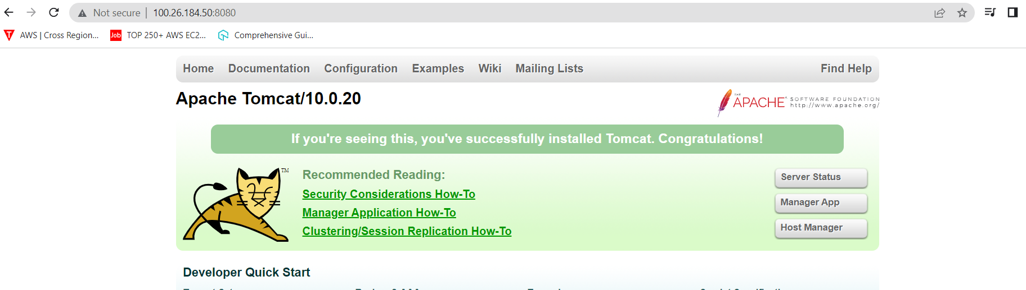

. go to mage guid (acces denied because we edit context.xml file) and manager guid permissions.

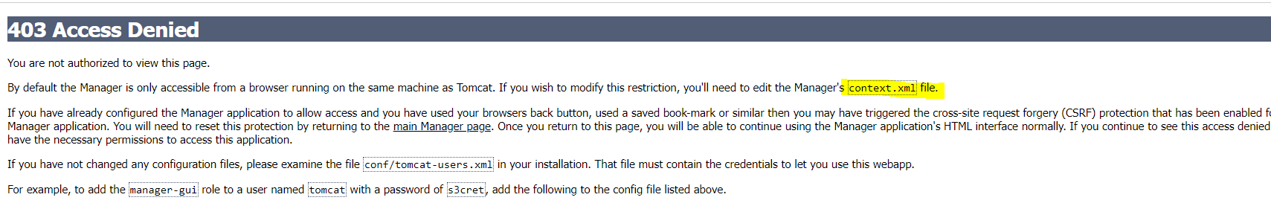

We edit host-manager and manager

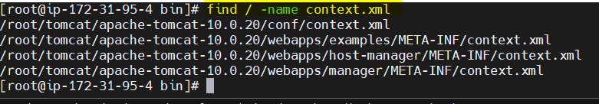

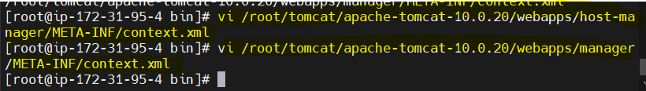





. now we can restart the tomcat service

. ./shutdown.sh

. ./startup.sh

. refresh service

. tomcat server is asking username and password

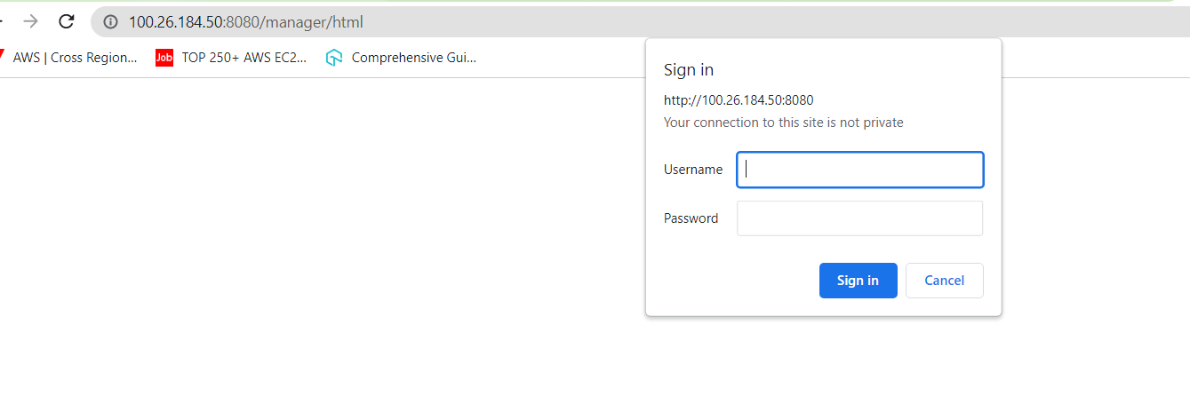

. we create login credentials in  conf/tomcat-users.xml

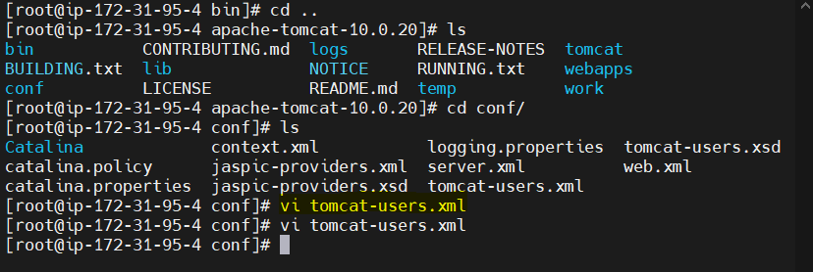

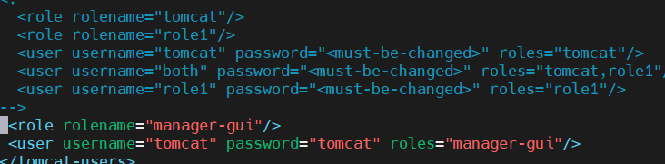

. restart the service

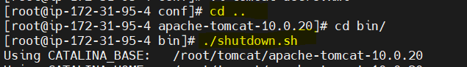



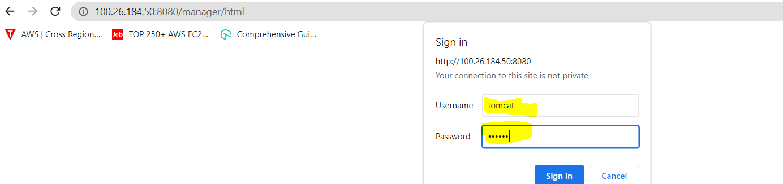

. tomcat server as started

